Travis Scott

IT- 230  
  
  
  
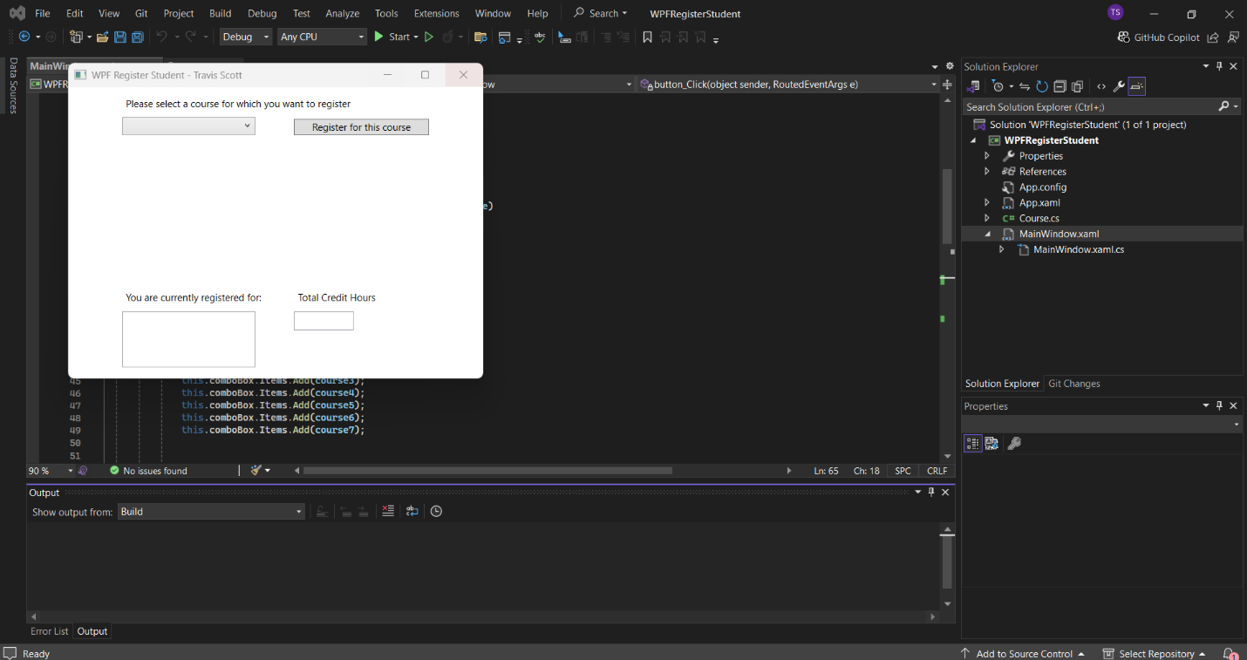  
This screenshot shows that the program compiles and outputs this window.  
This screenshot shows a successful registration for IT 145 while also keeping track of the current credit hours.  
This screenshot shows what the program does whenever a user accidentally signs up for the same class again.  
This screenshot shows a successful registration for IT 200, and like earlier, the program is keeping track of the accumulated credit hours.  
This screenshot shows a successful registration for IT 201, and the program has now reached 9 credit hours. The next screenshot will show what happens whenever a user tries to add more classes.   
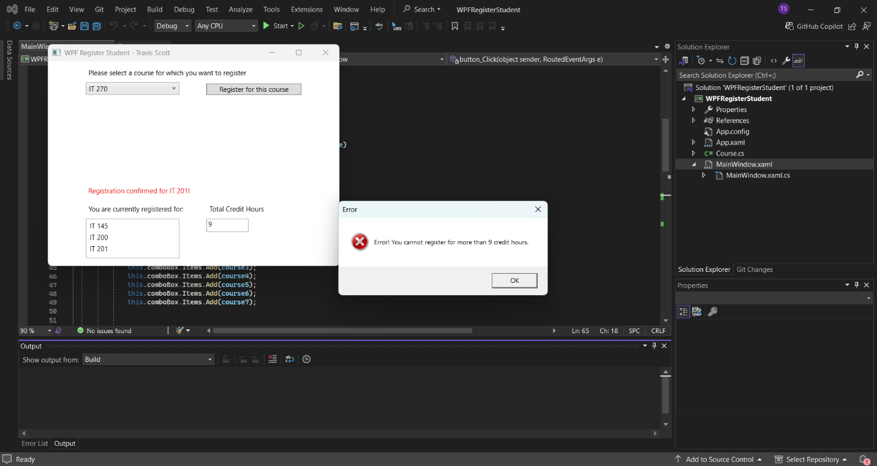  
This screenshot shows the error message that’ll occur whenever a user tries to register for more than 9 credit hours.  
  
using System;

using System.Collections.Generic;

using System.Linq;

using System.Text;

using System.Threading.Tasks;

using System.Windows;

using System.Windows.Controls;

using System.Windows.Data;

using System.Windows.Documents;

using System.Windows.Input;

using System.Windows.Media;

using System.Windows.Media.Imaging;

using System.Windows.Navigation;

using System.Windows.Shapes;

namespace WPFRegisterStudent

{

/// <summary>

/// Interaction logic for MainWindow.xaml

/// </summary>

public partial class MainWindow : Window

{

Course choice;

private int creditHours = 0;

public MainWindow()

{

InitializeComponent();

}

private void Window_Loaded(object sender, RoutedEventArgs e)

{

Course course1 = new Course("IT 145");

Course course2 = new Course("IT 200");

Course course3 = new Course("IT 201");

Course course4 = new Course("IT 270");

Course course5 = new Course("IT 315");

Course course6 = new Course("IT 328");

Course course7 = new Course("IT 330");

this.comboBox.Items.Add(course1);

this.comboBox.Items.Add(course2);

this.comboBox.Items.Add(course3);

this.comboBox.Items.Add(course4);

this.comboBox.Items.Add(course5);

this.comboBox.Items.Add(course6);

this.comboBox.Items.Add(course7);

this.textBox.Text = "";

}

private void button_Click(object sender, RoutedEventArgs e)

{

choice = (Course)(this.comboBox.SelectedItem);

if (choice != null)

{

if (this.listBox.Items.Contains(choice) && choice.IsRegisteredAlready())

{

MessageBox.Show("Error! You have already selected this course.", "Error", MessageBoxButton.OK, MessageBoxImage.Error);

}

else if (creditHours < 9) // Total credit hours cannot exceed 9 credit hours

{

this.listBox.Items.Add(choice); // Add each select to the output box of course.

choice.SetToRegistered();

creditHours += 3; // Each course has 3 credit hours each and is updated.

this.textBox.Text = Convert.ToString(creditHours); // TextBox is the credit hour text box displayed.

label3.Content = $"Registration confirmed for {choice.getName()}!"; // Print string when each eligible course is added.

}

else if (creditHours == 9) // if credit hours exceed 9

{

MessageBox.Show("Error! You cannot register for more than 9 credit hours.", "Error", MessageBoxButton.OK, MessageBoxImage.Error);

// A message box warning the user they are trying to register for over 9 credit hours, which is not allowed.Has error icon and ok button to exit.

}

else

{

MessageBox.Show("Error! No course selected, please try again.", "Error", MessageBoxButton.OK, MessageBoxImage.Error);

// An error message if nothing is selected

}

}

}

}

}